“I Didn’t Know the Census Bureau Did That!”

(Mining for Data Linked to the Census Bureau’s Home Page)
www.census.gov

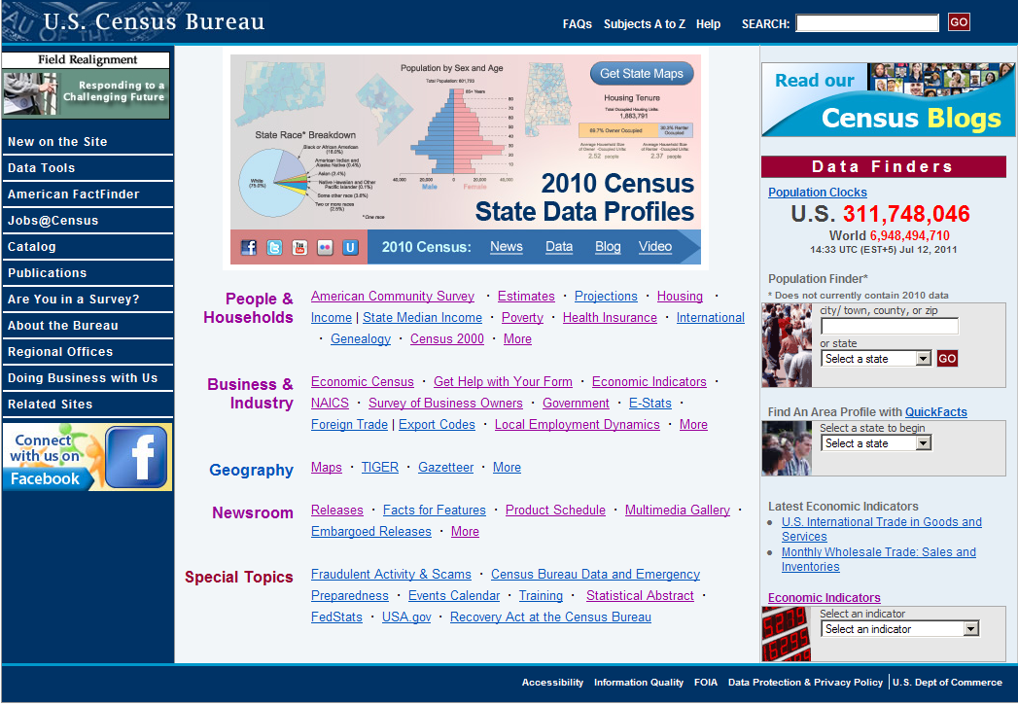

Top Banner
- FAQs - - searchable database
- Subjects A to Z
    - “S” - - Surveys Conducted by The Census Bureau (descriptions, not data)
  - Demographic Surveys
    - Demographic Survey Abstracts - - Descriptions of many surveys conducted by the Census Bureau: title, purpose, survey design and sample size, type of respondent, sponsoring agency and legal authorities, periodicity, information on release of results, historical background, special features, future outlook, and Census Headquarters contact person and telephone number)
  - Economic Surveys
- Help
- SEARCH - - powered by Google
Right Frame: Data Finders - - quick, simple searches
- Population Clocks - - U.S. and World clocks update continuously for one minute, then once per minute
- Population Finder
    - Demographic Profiles from the 2010 Census
    - Alphabetical listing or ranking by population of all cities and counties in a state
    - Map of persons per square mile, state by county
- Quick Facts
- For state, county, or city (incorporated, with population of 5,000 or more)
  - Contains basic information on population, housing, businesses, and geography
- Economic Indicators > (Select an indicator) View all
  - Current data, mostly national level

Left Frame (blue column) - - selections
- American FactFinder (AFF)
  - Currently in transition from Legacy AFF (old) to AFF2 (new)
  - Fall 2011 - - Legacy American FactFinder sunsets
  - Programs on American FactFinder
    - Decennial Census
    - American Community Survey (and Puerto Rico Community Survey)
    - Annual Population Estimates
    - Economic Census
    - Annual Economic Surveys
- Publications > Census of Population and Housing > (select year) ARCHIVED DATA FILES
- Are You in a Survey? (See handout.)
  - Legal authority for gathering data
  - Federal law, privacy principles, and statistical safeguards
- Regional Offices

Middle Frame
- People and Households
  - Income (Main tab)
    - (left column - - Quick Links) Guidance about Sources (scroll down to bottom of page for recommended sources)
  - Poverty (Main tab)
    - (left column - - Quick Links) Poverty Thresholds
    - (left column - - Quick Links) Poverty Data Sources > Description of income and poverty data sources (scroll down to bottom of page for data source recommendations)
    - (right column - - Related Sites) Small Area Income and Poverty Estimates (SAIPE)

Problem: Find the latest number of children (ages 5 to 17) in families in poverty in the Santa Maria-Bonita Elementary School District in California.

Path: www.census.gov > (People & Households) Poverty > (Related Sites) Small Area Income and Poverty Estimates (SAIPE) > (Quick Links) School District Data > Create interactive tables > 2009 - California – Continue > Santa Maria-Bonita Elementary School District – Display
Data

Answer: 2009 (released December 2010) - - 3,179

  - Business & Industry > (tab) Data by Geography – (tab) Counties > County Business Patterns (Select a state) California – Go! > (Areaname – these are counties) Los Angeles – Go! > Detail selection drills down on the NAICS code (from 2-digit to 6-digit) and Compare selection lists other counties in California and state totals.
  - Economic Census > (tab) User Guide > Uses of the Data
  - NAICS (North American Industry Classification System)
  - Local Employment Dynamics > (Quick Links) Industry Focus

Problem: You are a 35-year old woman working in the telecommunications (resale) field and are interesting in relocating in Berkeley, California. First you want to know about the starting pay (most important to you) in your industry, the number of new hires, the average monthly earnings for all workers, and the total employment in the industry - - for women in your age group. (Hint: Find the NAICS 3-digit code for the telecommunications industry first.)

Path: www.census.gov > Business & Industry – NAICS > (top left column - - Enter keyword) telecommunications – 2007 NAICS Search > 517 is the industry code. Back to www.census.gov > Local Employment Dynamics > (left column – Quick Links – Tools) Industry Focus > List the top 10 (default) > Ranking Indicator column = Average monthly earnings for new hires > Include in report column = (3 selections) Employment, Number of new hires, and Average monthly earnings for all workers > Age = 35-44 > Sex = Female > State = California > Entity = County = 001 Alameda > Select Industry Level = Industries > Industry Section = 51 Information > Detailed Industry = 517 Telecommunications > View Report. (Note the sentence under the heading Industry Focus now reads, “List the top 10 industries including 517 Telecommunications ranked by the greatest.” In this case the ranking factor is Average monthly earnings for new hires, so the greatest will be the highest earnings for new hires.

Answer: Average monthly earnings for women 35-44 in the telecommunications industry in Alameda County, California - - $6,875 per month. (Note this is for the last two quarters of 2009 and the first two quarters of 2010, the latest available.) (See next page for the appropriate entries per the directions above, as well as the resulting report.)
DATA ENTRIES:
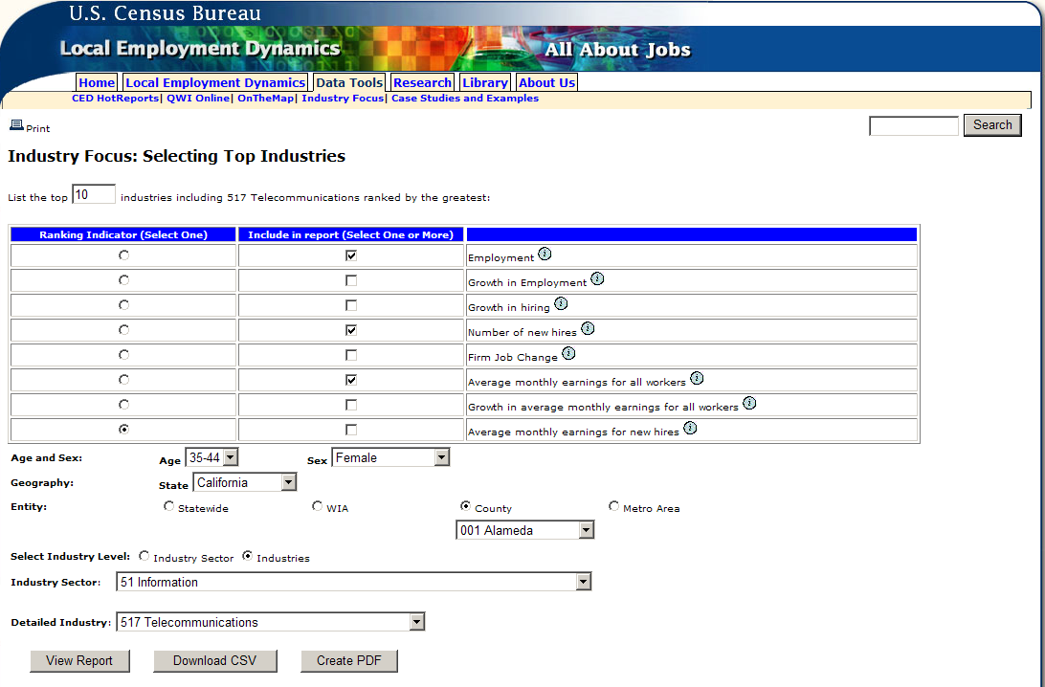
REPORT:
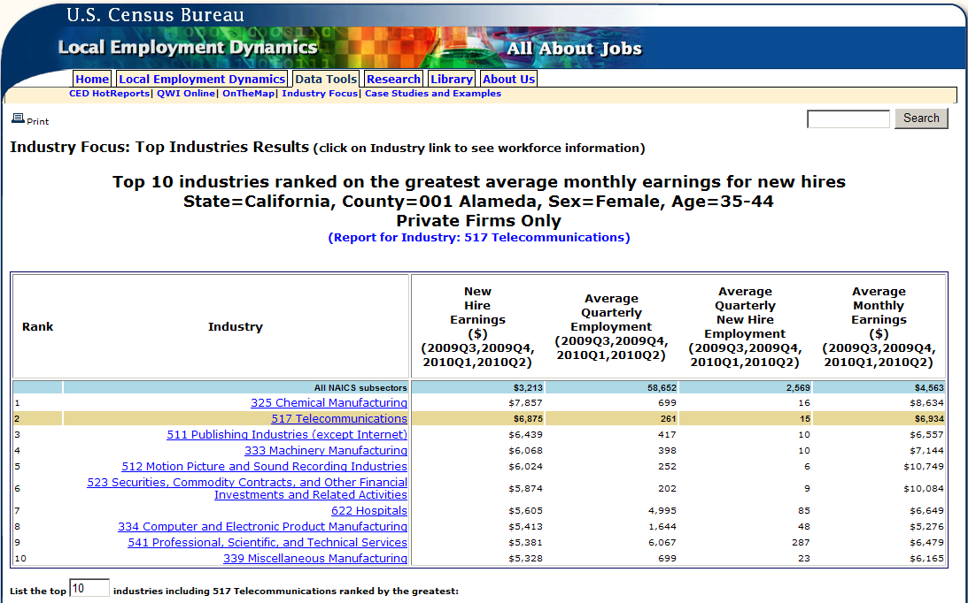

- Business & Industry (continued)
  - Survey of Business Owners

Problem: You would like information on Chinese-owned businesses in San Francisco:
(1) What is the total number of Chinese-owned firms? (2) How many of these firms have employees? (3) What is their total number of employees? (4) How many are nonemployer firms?

Path: www.census.gov > Business & Industry > Survey of Business Owners (SBO) > (middle frame) Asian – Data on American Fact Finder – Race Detail > (lower blue menu bar) Filter Rows (drop down) By Geography > (instructions following second brown box) Select a geographic type - County > Select a state – California > Select one or more geographic areas – San Francisco County (highlight) – Add (Get rid of the United States selection, which is a default, by highlighting it and clicking Remove) > Show Result

Answers:
(1) 13,006 Chinese-owned firms;
(2) 3,147 have employees;
(3) 21,646 employees total; and
(4) 9,859 are nonemployer firms (note that (2) and (4) = (1) the total number of firms)

- Business & Industry (continued)
  - Government > (lower left side of page - Special Topics) Library Statistics > (left column) Data Files
- Geography
  - Maps > Map Products > 2010 Census Reference (block, census tract, etc.)
- Newsroom
  - Releases
  - Multimedia Gallery > Radio > (left) In this Section - - Profile America (by date - - audio and script) INTERESTING DAILY FACTOIDS!
  - Tip Sheets
- Special Topics
  - Statistical Abstract
    - Published since about 1878
- 2012 probably to be last printed version - - online version only starting in 2012

Tip: You can return to the Home Page by clicking on the
blue banner (U.S. Census Bureau) at the top of most pages.

