
Northwest Government Information Network

Spring Meeting
Spokane Restaurant Guide

Friday, April 25, 2008
Gonzaga University School of Law
Chastek Law Library, 721 N. Cincinnati
Spokane WA

Possible Places to Eat:

On Campus:

- Café Lawte in the Law School: coffee and drinks, with a small selection of pre-made sandwiches, salads, muffins, etc.

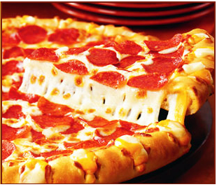
- Marketplace: several options in the basement of the COG- pizza, subs, vegetarian, salads, soups.

Off Campus But Very Close:

- David's Pizza 829 E. Boone (Boone & Hamilton)

- Ultimate Bagel, Starbucks, and the Pita Pit (Sharp & Hamilton)

- Chapala Mexican restaurant 1801 N. Hamilton

- Ionic Burrito 1415 N. Hamilton

- Riverview Thai 1003 E. Trent

- Pho Van 1210 N. Hamilton

- Pete's Pizza 821 E. Sharp

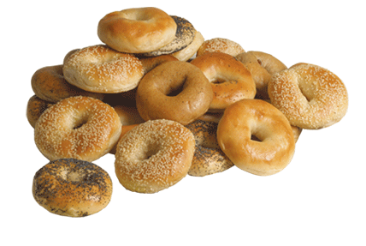
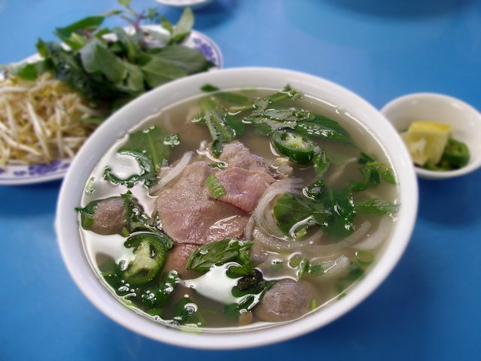
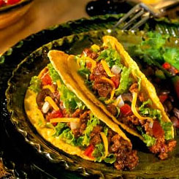
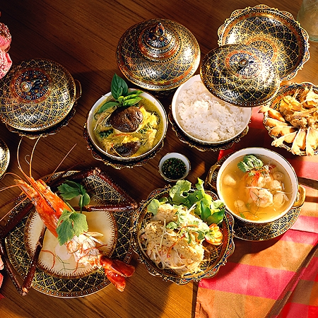

Disclaimer: the photos on this food guide are decorative elements. They do not reflect what the meals will look like at the restaurants suggested.

