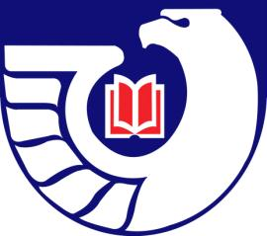
Northwest Government Information Network
Spring Meeting 2010
May 14, 2010
Spokane Public Library

The Northwest Government Information Network met at Spokane Public Library and began the meeting with a tour of the library and the Northwest History Room by Jean Hartman.

Minutes of business meeting
Present: Carlos Diaz, Sandra Dyer, Jean Hartman, Cass Hartnett, Jan Jorgenson, Justin Otto, Judy Solomon, Marilyn Von Seggern

The meeting was called to order by President Justin Otto. Election of 2010-11 officers was added to the agenda.

Treasurer’s Report—Jean Hartman—the balance is $917.62. We have added 2 new members and 3 new student members.

Secretary’s Report—Justin gave a report for Robin Clausen. The minutes of the previous meeting were approved via e-mail.

2011 WLA Program Planning—Justin Otto offered to lead the planning on a documents-related program for the WLA Conference in Yakima, April 6-8, 2011. One idea is to focus on free public access to some of the newer federal online databases such as FDSys, Regulation.gov, and Thomas. He will be in touch via e-mail to do the program planning.

Regional Librarians’ Report—Justin Otto for Lori Smith Thornton—there was no news. The state plan for federal depository libraries was not finalized. In discussion this was identified as the topic for the fall meeting which could be held in the Olympia area to enable Lori to attend.

Report from Depository Library Council—Justin Otto—Justin reviewed the Federal auditor’s report on GPO and the digitization and archiving of the legacy collection as 2 large issues of the Spring Conference.

Updates from members

Program
After lunch the group met at Gonzaga University Library to hear Stephanie Plowman, Special Collections Librarian, talk about the Nethercutt Congressional Papers and how the collection was received and processed. An Archival Assistant, Kathy Hill, had been working on the organization of the Papers and was nearly done.

