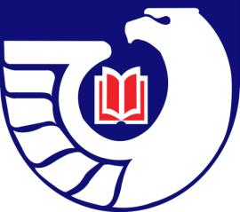**Northwest Government Information Network**

**Spring Meeting**

Friday, May 17, 2013

Washington State University

Pullman, WA

***RDA for Beginners***

***(with an emphasis on Government Information)***

**Lori Robare**

**University of Oregon Libraries**

**Getting Settled-In:** 9:00am – 9:30am

* Registration and Refreshments
* Welcome and Introduction of Participants – Robert Lopresti

**Library Tour:** 9:30am – 10:00am

* Tour of Holland & Terrell Libraries and documents collections – Marilyn Von Seggern

**Special Guest Speaker:** 10:00am – 11:30am

* Lori Robare, University of Oregon Libraries

**Lunch:** 12:00pm – 1:30pm

**Business Meeting:** 1:30pm – 3:30pm

* Approval of Agenda – Justin Otto
* Review of Fall Meeting Minutes – Cass Hartnett
* Treasurer’s Report – Jean Hartman
* Webmaster’s Report – Carlos A. Diaz
* Regional Depository Librarian’s Report – Crystal Lentz
* Report from Depository Library Council Member – Peggy Jarrett
* Election of 2013-2014 NGIN Officers – Justin Otto
* Updates from Members

**Adjournment:** 3:30pm