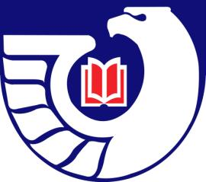
Northwest Government Information Network

Spring Meeting
Agenda

Friday, May 1, 2009
Central Washington University
Brooks Library
Room 206, Dean’s Conference Room
Ellensburg WA

Morning

9:00 - 9:30 am Registration and Refreshments (Brooks Library Room 206 – Dean’s Conference Room)

9:30 am – 12 noon Program: Looking ahead to the 2010 Census (Brooks Library Room 154)

Linda Clark
Information Services Specialist
U.S. Census Bureau, Seattle Regional Office

12 noon -1:00 pm Lunch

Afternoon

1:00 – 1:30 pm Library Tour

1:30 to 3:30 pm NGIN Business Meeting and FDLP Update (Brooks Library Room 206)

  - Treasurer’s Report – Jean Hartman
  - Secretary’s Report – Robin Clausen
  - 2009 NGIN Membership Survey – Carlos Diaz
  - Recognition for Retiring Librarians/Scholarships for MLIS Students – Carlos Diaz
  - 2010 WLA Program Planning – Justin Otto
  - Depository Library Council Meeting Report – Herrick Heitman
  - Report from Depository Library Council Member – Justin Otto
  - Election of 2009-2010 NGIN Officers
  - Updates from members

3:30 pm Adjourn

Revised: April 28, 2009

