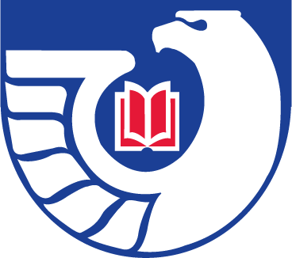**Northwest Government Information Network**

**Spring Meeting**

Monday, May 11, 2015

University of Idaho Libraries

Moscow, Idaho

**Getting Settled-In:** 9:00 am – 9:30 am

* Registration and Refreshments
* Welcome and Introduction of Participants – Peggy Jarrett

**Documents Potluck 2015: 9:30 -11:30**

* FGI 2.0: A Most Favorable Moveable Feast – Cass Hartnett
* Amuse-Bouche: Email as a Government Documents Discovery Tool—Lorena O’English
* The United States Code: A Recipe for Success – Peggy Jarrett
* FRUS: The Cornucopia of U.S. Diplomacy – Marilyn Von Seggern
* A Recipe for All Occasions: A Presentation on the Statutes at Large, the United States Code, and the Code of Federal Regulations for Use in Multiple Courses
* Delicious Documents Desserts – Rami Attebury

**Library Tour:** 11:30 pm – 12:30 pm

**Lunch:** 12:30pm – 1:30 pm

**Business Meeting:** 1:30 pm – 3:30 pm

* Approval of Agenda – Peggy Jarrett
* Review of Fall Meeting Minutes – Cass Hartnett
* Treasurer’s Report – Justin Otto
* Webmaster’s Report – Carlos A. Diaz
* Regional Depository Librarian’s Report – Crystal Lentz
* Updates from Members
* Election of Program Chair/President-Elect
* Welcome Ramirose Attebury as President for 2015/2016
* Next meeting

**Adjournment:** 3:30 pm