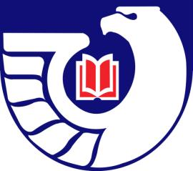

Northwest Government Information Network
Fall Meeting 2011

Friday, November 4, 2011
Washington State Library--Olympia
Central Washington University--Ellensburg

Census 2010:
Using American Factfinder 2

Linda Clark
U.S. Census Bureau
Seattle Regional Office

Getting Settled-In: 9:00 a.m. – 9:30 a.m.
Registration and Refreshments
Washington State Library
Central Washington University

Library Tour: 9:30 am – 10 am
Washington State Library
Central Washington University

Special Guest Speaker: 10 am – 11:30 am from WSL – Olympia site
Linda Clark
U.S. Census Bureau
Seattle Regional Office

Lunch: 12 noon - 1:30 p.m.

Business Meeting: 1:30 p.m. - 3:30 p.m.

- Introductions of Participants
- Review of Spring Meeting Minutes – Cass Hartnett
- Treasurer's Report – Sue Anderson on behalf of Jean Hartman
- Webmaster’s Report – Carlos A. Diaz
- Regional Depository Librarian’s Report – Lori Thornton

Page 2

- Depository Library Council Meeting Report – Peggy Jarrett
- Locations and Logistics for future NGIN meetings- Dan Waters
- Spring 2012: theme and location(s) and Election of Program Chair and Treasurer

