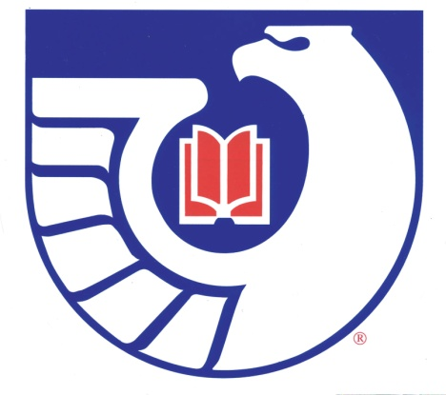

## NGIN *Northwest Government Information Network Membership Form January - December 2015*

Please print out this form. Send the Membership Form and a $10.00 check or cash to:

|  |
| --- |
| Justin Otto  Eastern Washington University  JFK Library 100 LIB  816 F. Street  Cheney, WA 99004-2453 email: [jotto@ewu.edu](mailto:jotto@ewu.edu) |

**Please Make Checks Payable to: Justin Otto, with NGIN in the note field.**

Name:

Institution:

Address:

Telephone Number:

Fax:

Email:

Would you like to receive a receipt of payment?   _____ Yes     _____  No   
    
 

|  |
| --- |
| Annual Membership Dues: $10.00 |

Revised: May 6, 2015.