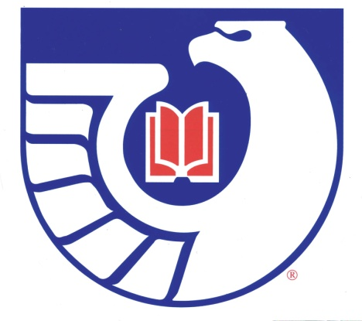

## NGIN *Northwest Government Information Network Library Graduate Student Membership Form January - December 2015*

Library Student Membership is FREE!!

Please fill out this form and email the membership form to:

Justin Otto

E-mail: [jotto@ewu.edu](mailto:jotto@ewu.edu)

Name:

Library School:

Year & Quarter/Semester Graduating:

Address:

Telephone Number:

Email:

Library Student Membership is good for the calendar year and must be renewed every January. Be sure to fill this form in order to keep your membership current.

Library Graduate Student Membership is available to current students of ISchool at UW and to Library and Information Science distance learning program students residing in Washington, Idaho, Alaska, and Hawaii.

NGIN members communicate with each other via the NGIN listserv. Just follow the [instructions](http://ngin.askcarlos.com/listserv-ngin.doc) in order to subscribe.

    
 Created by Carlos A. Diaz. Revised May 6, 2015.